|  |  |  |
| --- | --- | --- |
|  |  |  |

GOVERNMENT OF INDIA

**MINISTRY OF SKILL DEVELOPMENT & ENTREPRENEURSHIP**

DIRECTORATE GENERAL OF TRAINING

**NATIONAL SKILL TRAINING INSTITUTE**

NSTI(W), Trivandrum

PROJECT DOCUMENT

**“HEART FAILURE CLINICAL RECORDS”**

|  |  |  |
| --- | --- | --- |
|  |  |  |

**Submitted by**

Arya N R

**Under the Guidance of**

Poovargavan Velumani

**ABSTARCT**

Here I take the **HEART** **FAILURE CLINICAL RECORDS** Cardiovascular diseases (CVDs) are the **number 1 cause of death globally**, taking an estimated **17.9 million lives each year**, which accounts for **31% of all deaths worlwide**.  
Heart failure is a common event caused by CVDs and this dataset contains 12 features that can be used to predict mortality by heart failure.

INDEX

1. **INTRODUCTION**
2. **OBJECTIVE/ PROJRCT OVER VIEW**
3. **PROJECT DESCRIPTION**
4. **REQUIREMENT ANALYSIS**
   1. Hardware Requirement
   2. Software Requirement

INTRODUCTION

Here I select the topic **HEART FAILURE CLINICAL RECORDS.** A **sample data set** contains a part, or a subset, of a population. The size of a **sample** is always less than the size of the population from which it is taken.

Microsoft Excel is a helpful and powerful program for data analysis and documentation. It is a spreadsheet program, which contains a number of columns and rows, where each intersection of a column and a row is a “cell.” Each cell contains one point of data or one piece of information.

A data set (or dataset) is a collection of [data](https://en.wikipedia.org/wiki/Data). In the case of tabular data, a data set corresponds to one or more [database tables](https://en.wikipedia.org/wiki/Table_(database)), where every [column](https://en.wikipedia.org/wiki/Column_(database)) of a table represents a particular [variable](https://en.wikipedia.org/wiki/Variable_(computer_science)), and each [row](https://en.wikipedia.org/wiki/Row_(database)) corresponds to a given record of the data set in question. The data set lists values for each of the variables, such as height and weight of an object, for each member of the data set. Each value is known as a datum. Data sets can also consist of a collection of documents or files.

OBJECTIVE/ PROJRCT OVER VIEW

Here I take the **FAILURE CLINICAL RECORDS** Cardiovascular diseases (CVDs) are the **number 1 cause of death globally**, taking an estimated **17.9 million lives each year**, which accounts for **31% of all deaths worlwide**.  
Heart failure is a common event caused by CVDs and this dataset contains 12 features that can be used to predict mortality by heart failure. Most cardiovascular diseases can be prevented by addressing behavioural risk factors such as tobacco use, unhealthy diet and obesity, physical inactivity and harmful use of alcohol using population-wide strategies.People with cardiovascular disease or who are at high cardiovascular risk (due to the presence of one or more risk factors such as hypertension, diabetes, hyperlipidaemia or already established disease) need **early detection** and management wherein a machine learning model can be of great help.

PROJECT DESCRIPTION

Microsoft Excel is a helpful and powerful program for data analysis and documentation. It is a spreadsheet program, which contains a number of columns and rows, where each intersection of a column and a row is a “cell.” Each cell contains one point of data or one piece of information.

And it is a spreadsheet developed by Microsoft for Windows, macOS, Android and iOS. It features calculation, graphing tools, pivot tables, and a macro programming language called Visual Basic for Applications. A data set (or dataset) is a collection of [data](https://en.wikipedia.org/wiki/Data). In the case of tabular data, a data set corresponds to one or more [database tables](https://en.wikipedia.org/wiki/Table_(database)), where every [column](https://en.wikipedia.org/wiki/Column_(database)) of a table represents a particular [variable](https://en.wikipedia.org/wiki/Variable_(computer_science)), and each [row](https://en.wikipedia.org/wiki/Row_(database)) corresponds to a given record of the data set in question. The data set lists values for each of the variables, such as height and weight of an object, for each member of the data set. Each value is known as a datum. Data sets can also consist of a collection of documents or files. The purpose of Datasets is to avoid directly communicating with the database using simple SQL statements. The purpose of a Dataset is to act as a cheap local copy of the data you care about so that you do not have to keep on making expensive high-latency calls to the database.

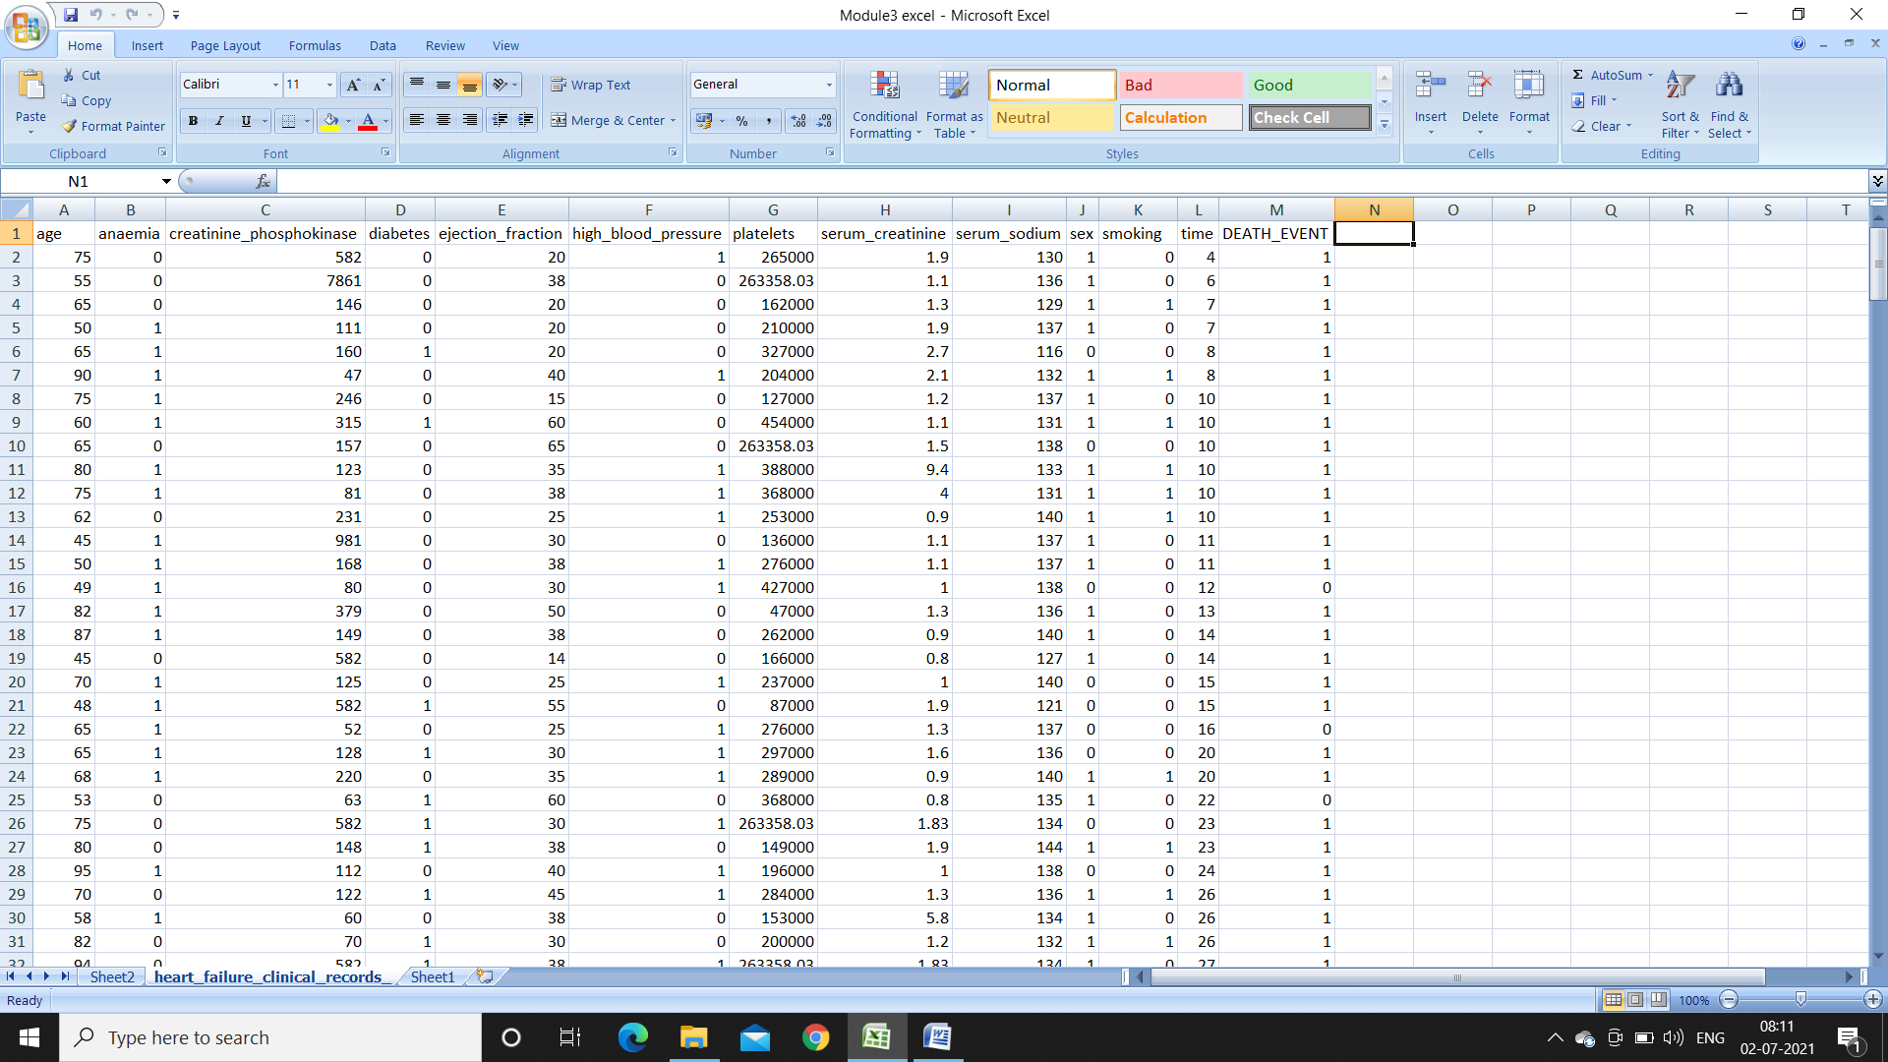

A data set (or dataset) is a collection of [data](https://en.wikipedia.org/wiki/Data). In the case of tabular data, a data set corresponds to one or more [database tables](https://en.wikipedia.org/wiki/Table_(database)), where every [column](https://en.wikipedia.org/wiki/Column_(database)) of a table represents a particular [variable](https://en.wikipedia.org/wiki/Variable_(computer_science)), and each [row](https://en.wikipedia.org/wiki/Row_(database)) corresponds to a given record of the data set in question. The data set lists values for each of the variables, such as height and weight of an object, for each member of the data set

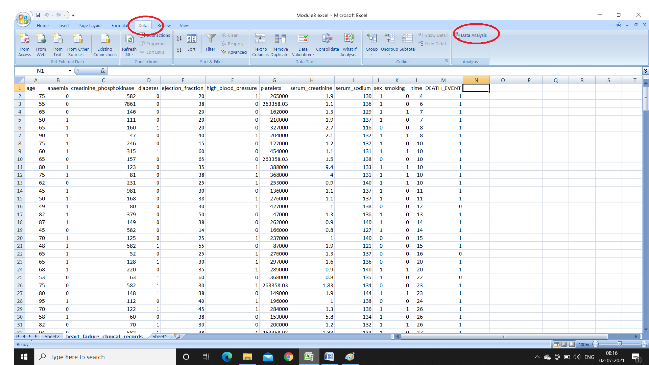

**HEART** **FAILURE CLINICAL RECORDS** Cardiovascular diseases (CVDs) are the **number 1 cause of death globally**, taking an estimated **17.9 million lives each year**, which accounts for **31% of all deaths worlwide**.  
Heart failure is a common event caused by CVDs and this dataset contains 12 features that can be used to predict mortality by heart failure.

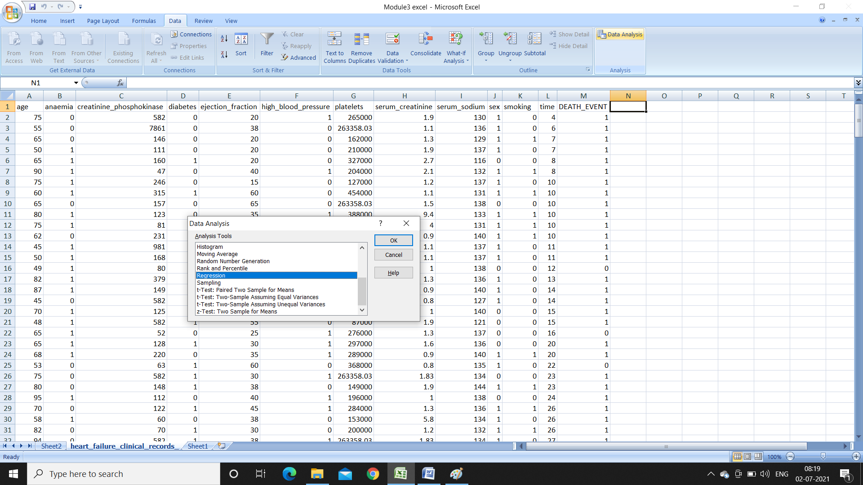

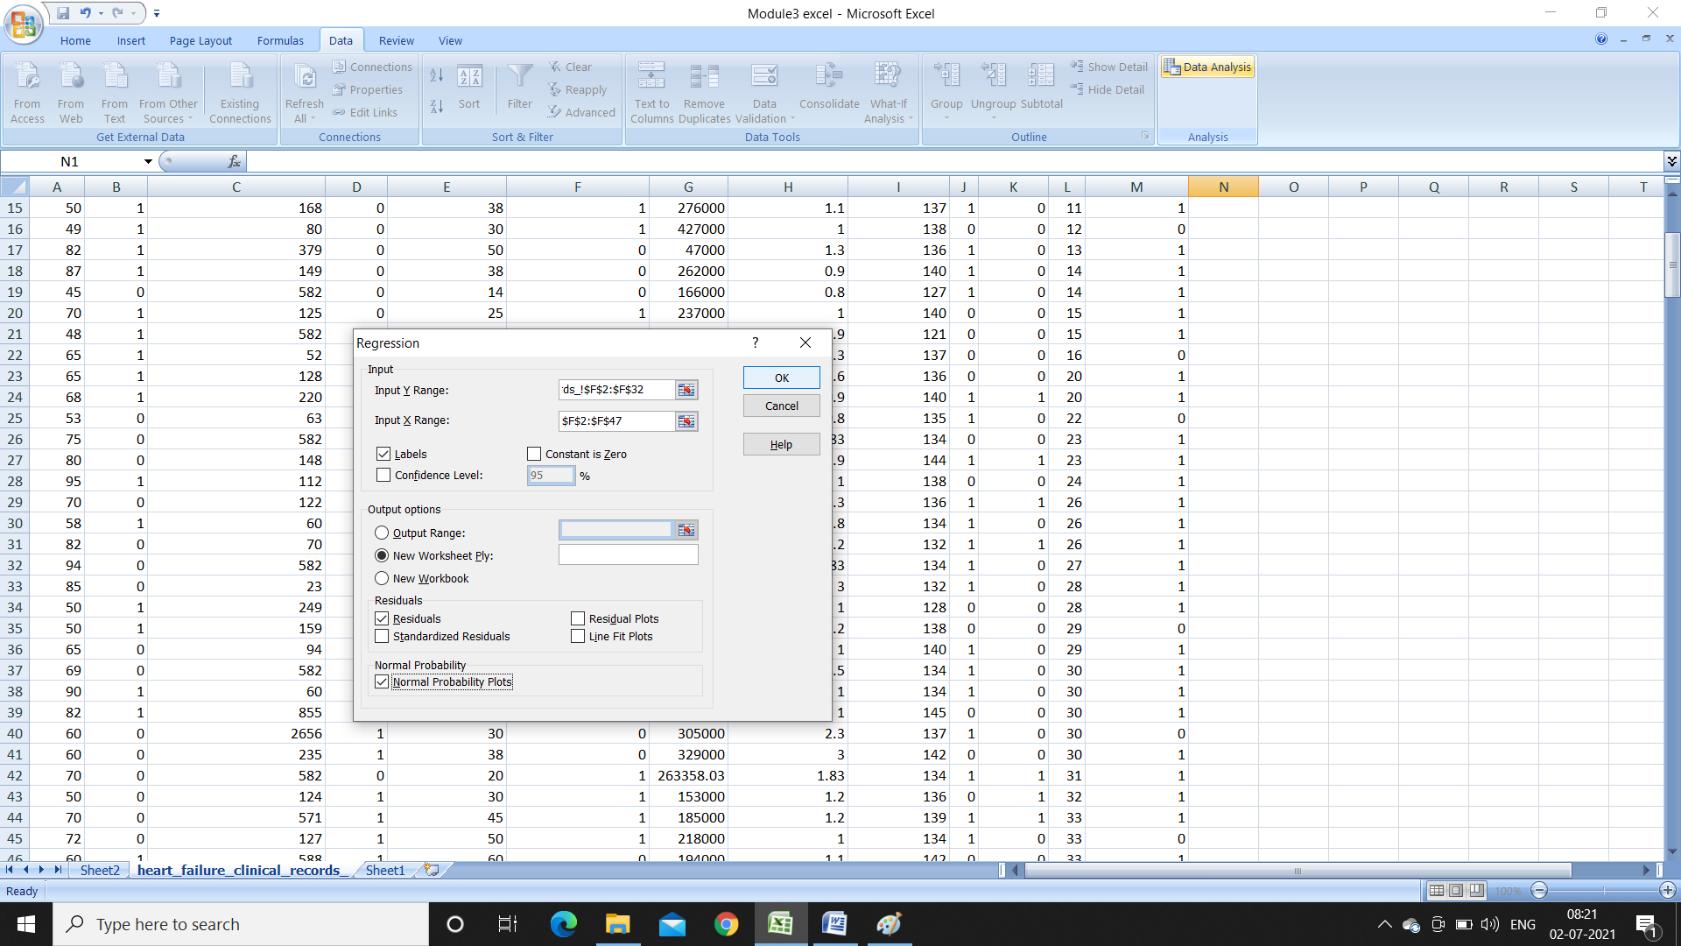

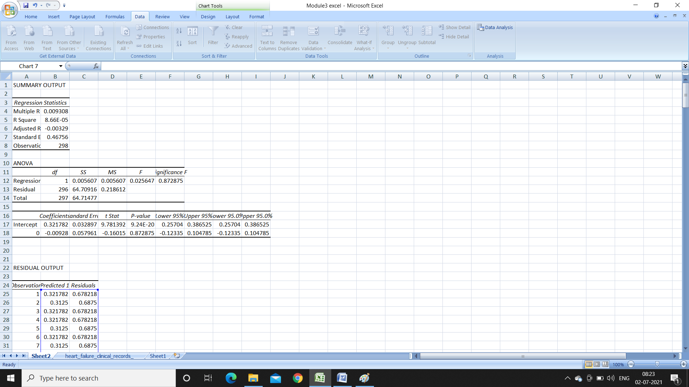

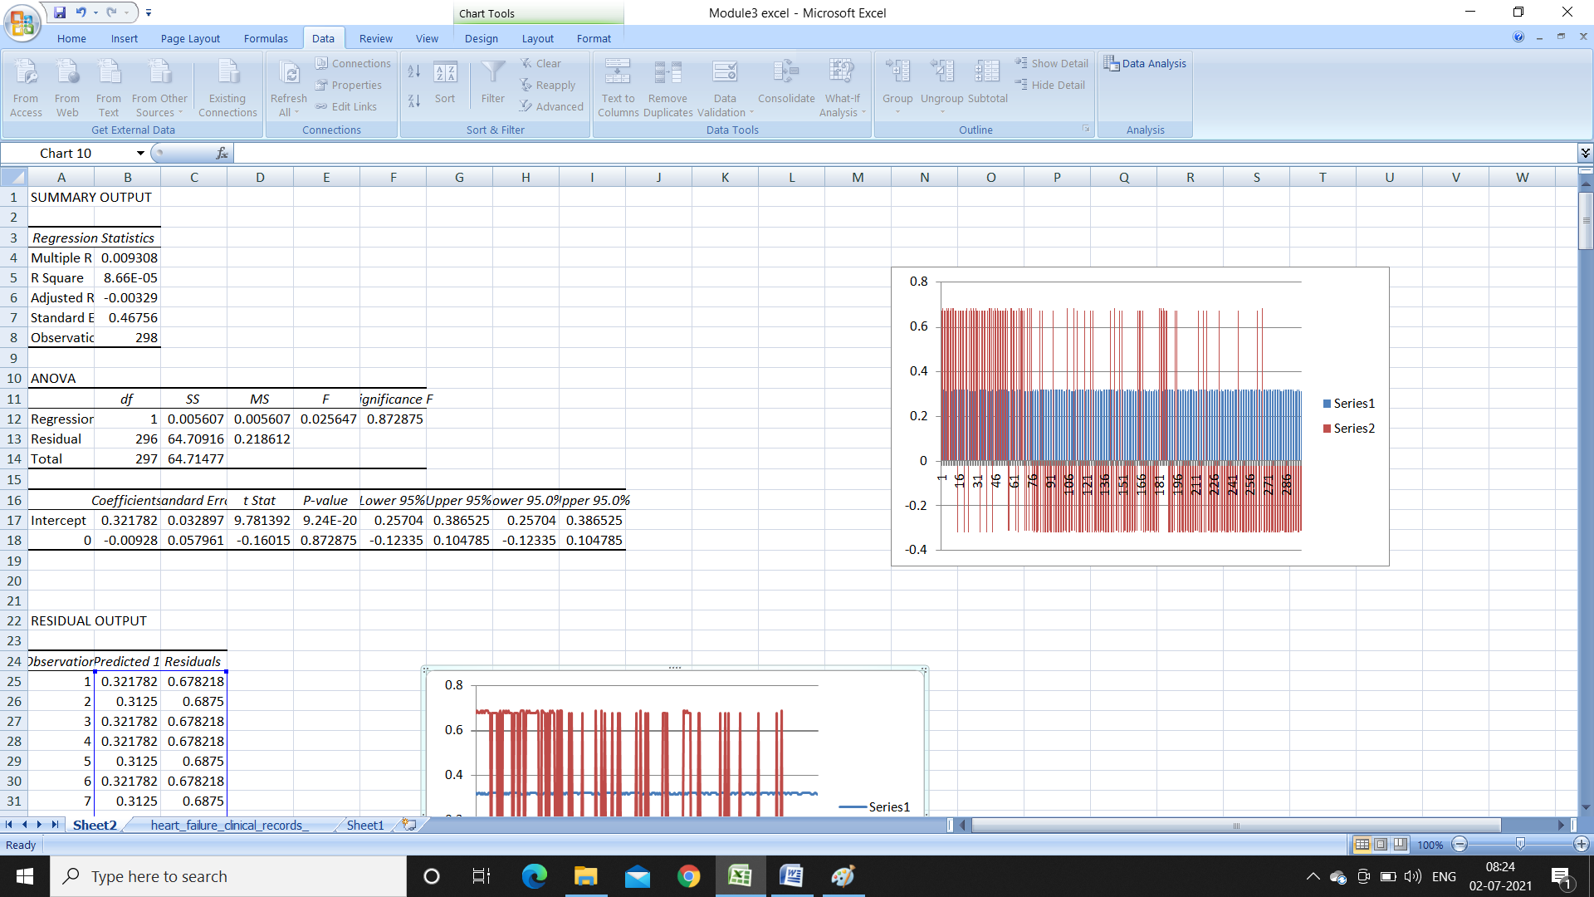

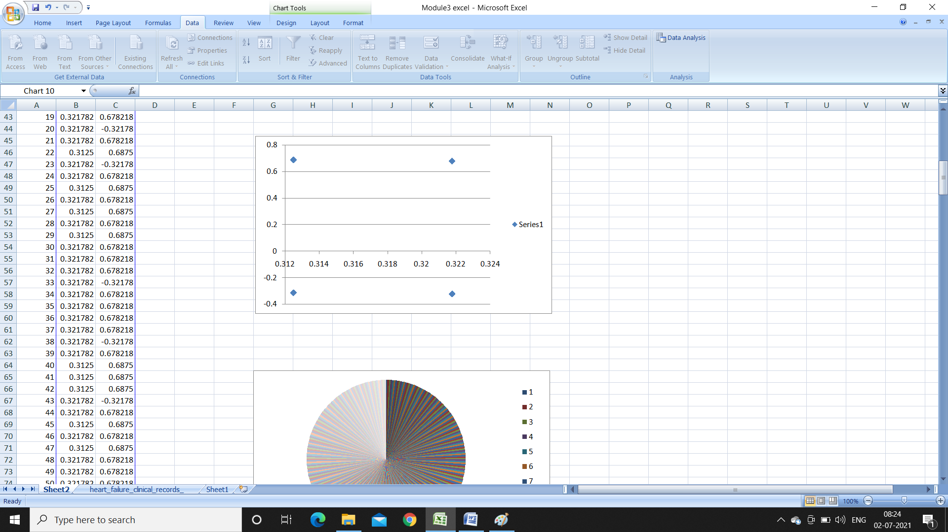

REQUIREMENT ANALYSIS

HARDWARE REQUIREMENTS

Processor : Intel(R) core

RAM Size : 4.00GB

Hard Disk Capacity : 97.1 GB

Monitor Type : color monitor

SOFTWARE REQUIREMENTS

Operating System : Windows7, Windows 10

Internet Connection : Existing telephone lines

Browser : Google chrome

Tool : MS Excel